**Aim:**

**a) Basic operations using pandas like series, data frames, indexing, filtering, combining and merging data frames.**

**b) Different Linear algebra functions using Scipy.**

**a) Basic operations using pandas like series, data frames, indexing, filtering, combining and merging data frames.**

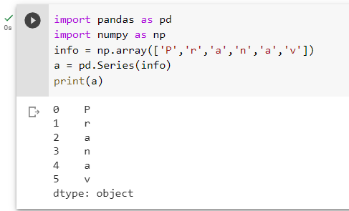

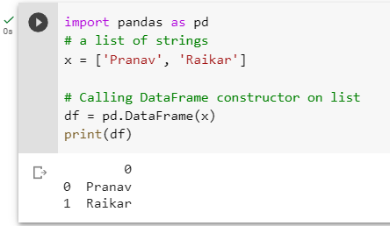

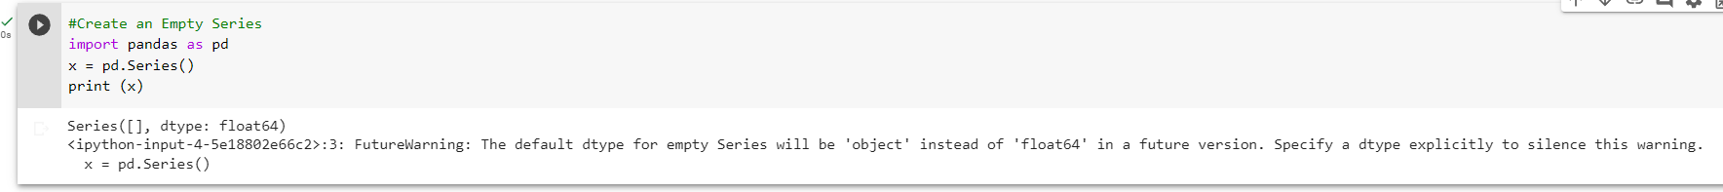

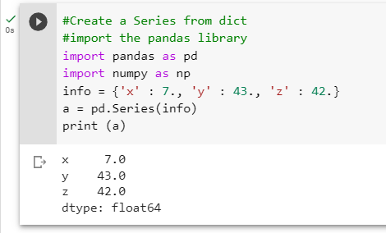

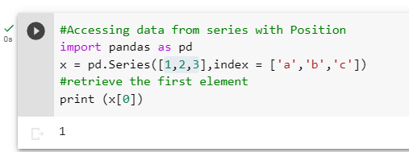

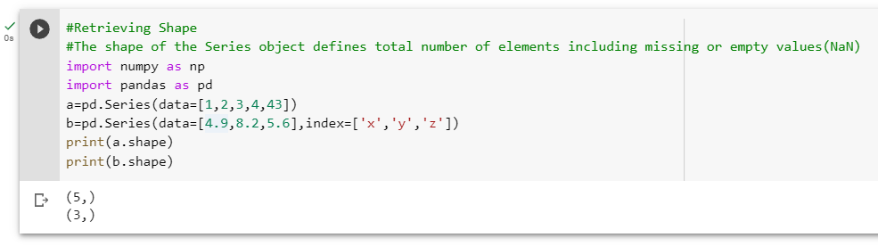

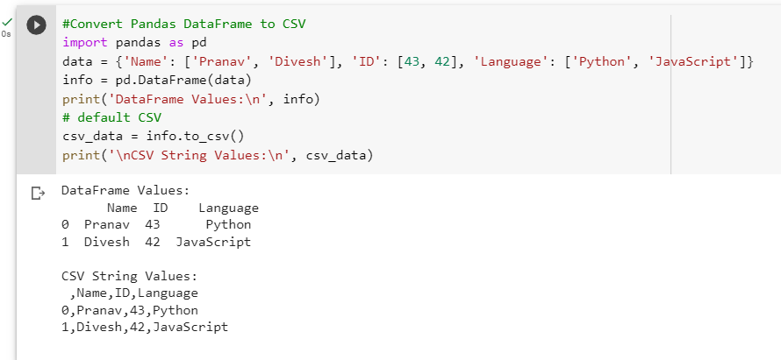

**b) Different Linear algebra functions using Scipy.**

